
WECON Program

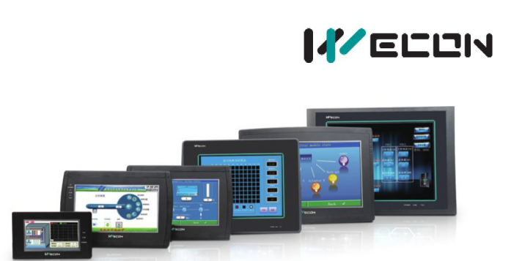

WECON Technology Co., Ltd.

Website: http://www.we-con.com.cn/en

Technical Support: chengxf@we-con.com.cn

Skype: Jason.chen842

Phone: 86-591-87868869

¹ WECON Technology Co., Ltd.

How to make RS485 RS422 RS232 cable

1. RS485 Wiring diagram
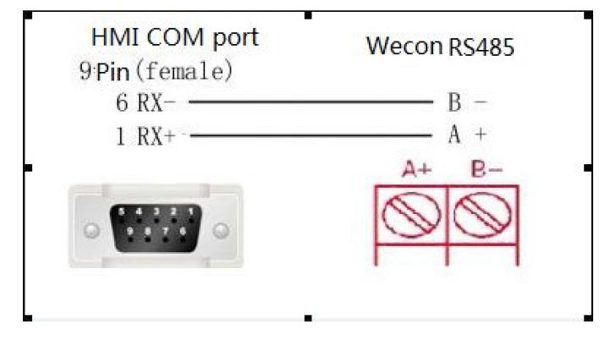

RS422 Wiring diagram
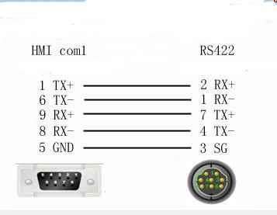

Our PLC can’t support RS232

2-------- | 3
3-------- | 2
5-------- | 5

² WECON Technology Co., Ltd.

- Com1 support RS485 and RS422,Please check the following picture.
(>=24 point PLC support COM1 RS485/RS422 and COM2 RS485,for example:LX3V-1410.less than 24 point plc only support COM1 RS422 and COM2 RS485,for example LX3V-0806/LX3V-1208)
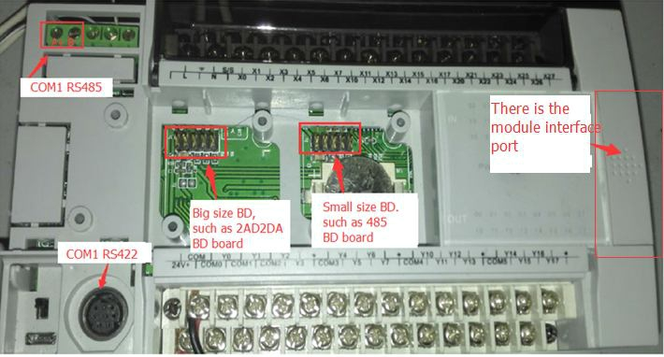

- Our Com2 support RS485,Please check the following picture.
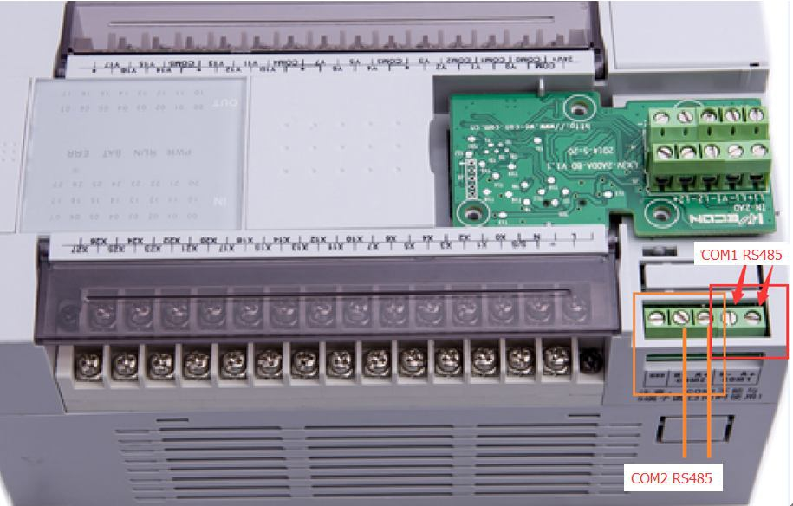

LX3V-0806/LX3V-1208 plc only can support COM1 RS422 and COM2 RS485.
LX3V-0806/LX3V-1208 plc com2 rs485 port is in below.Note:(LX3V-0806/LX3V-1208 plc can not support connect module.because it does not with module port)
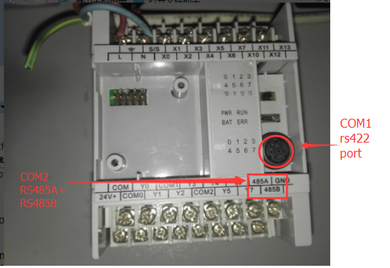

Note:COM2 could support Wecon PLC protocol and Modbus RTU protocol.So user need to set plc parameter in D8120 and D8126 to choose use which protocol.

For example(Wecon HMI connect Wecon PLC COM2 by Wecon PLC protocol)
HMI parameter is in the picture below.(Setting--->Communication)
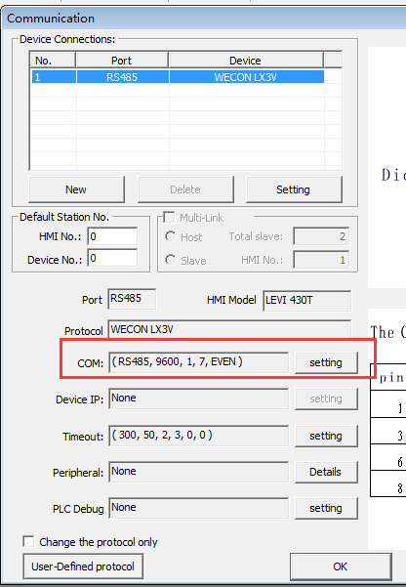
PLC program example.

D8120 means communication parameter format(9600,1,7,EVEN)---->D8120=10000110(2)=86(Hex)
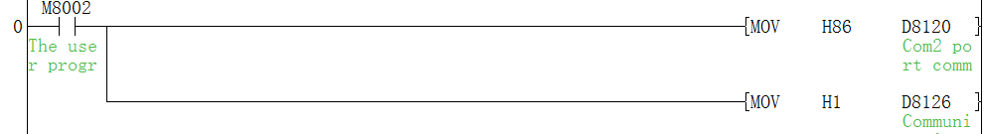
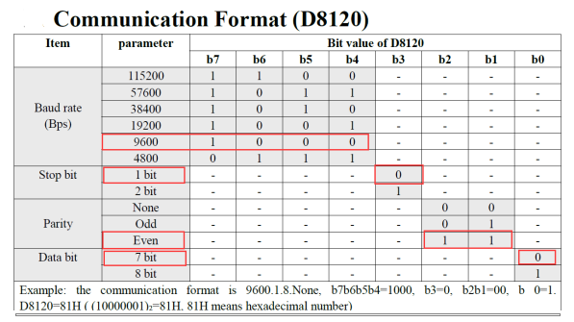

D8126=01H means use Wecon PLC protocol.

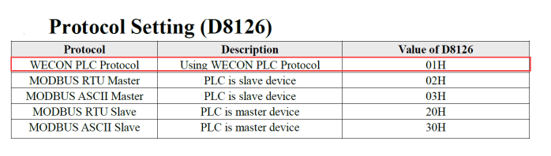

³

